Chris Park CSCD340 Lab 7

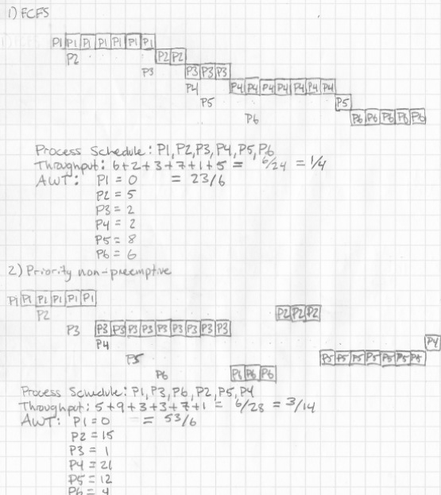
1) FCFS
Process Schedule: P1, P2, P3, P4, P5, P6
Throughput: 6 + 2 + 3 + 7 + 1 + 5 = 6/24 = 1 / 4
AWT: 23/6

2) Priority non-preemptive
Process Schedule: P1, P3, P6, P2, P5, P4
Throughput: 5 + 9 + 3 + 3 + 7 + 1 = 6/28 = 3/14
AWT: 53/6
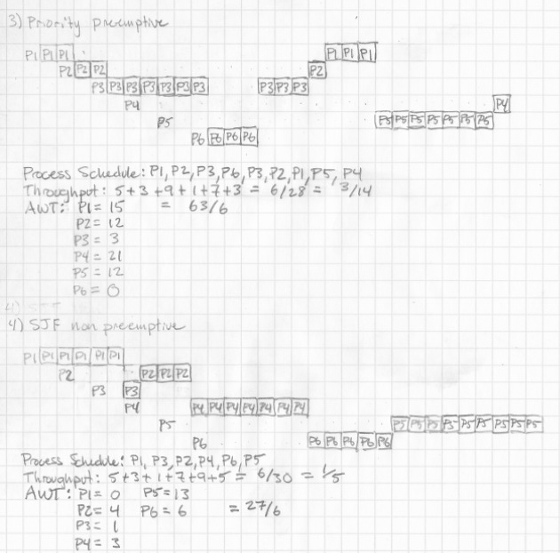

3) Priority preemptive
Process Schedule: P1, P2, P3, P6, P3, P2, P1, P5, P4
Throughput: 5 + 3 + 9 + 1 + 7 + 3 = 6/28 = 3/14
AWT: 63/6

4) SJF non-preemptive
Process Schedule: P1, P3, P2, P4, P6, P5
Throughput: 5 + 3 + 1 + 7 + 9 + 5 = 6/30 = 1 / 5
AWT: 27/6
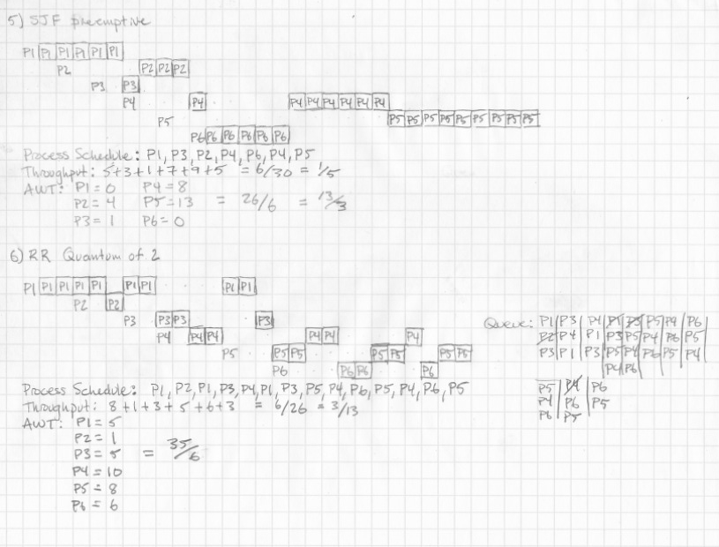
5) SJF preemptive
Process Schedule: P1, P3, P2, P4, P6, P4, P5
Throughput: 5 + 3 + 1 + 7 + 9 + 5 = 6/30 = 1 / 5
AWT: 13/3

6) RR Quantum of 2
Process Schedule: P1, P2, P1, P3, P4, P1, P3, P5, P4, P6, P5, P4, P6, P5
Throughput: 3/13
AWT: 35/6

